OFFICIAL COORDINATION REQUEST FOR
NON-ROUTINE OPERATIONS AND MAINTENANCE

COORDINATION DATE- 15 December 2011
PROJECT- Bonneville Lock and Dam
RESPONSE DATE- 23 December 2011

Description of the problem- The Corps (Sean Tackley is POC) and NOAA Fisheries (Mary Moser) are proposing minor modifications to The Dalles East Fish Ladder to improve Pacific lamprey passage.

NOAA Fisheries will fabricate and install approx. 45-degree aluminum ramps to two submerged orifices each on weirs 105 (immediately above the 180-degree bend in the overflow weir section of the ladder) and 153 (immediately downstream of the count station). The purpose of the ramps is to provide an attachment surface for lamprey attempting to pass these submerged orifices. All joints and end closures will be field fit welded, then ground smooth; all fasteners will be stainless steel and countersunk.

See Figures 1-3 below for detailed drawings and reference photographs.

Type of outage required- No additional outage required since the East ladder is currently dewatered for winter maintenance.

Impact on facility operation- The ramps are expected to be permanent fishway features and are expected to have little to no impact on fishway function. Ramps will be modified or removed if 2012 studies or The Dalles project staff identify problems with the structures.

Length of time for repairs- Ramp fabrication and installation will occur during the 2011/2012 IWW period, while the East Fish Ladder is dewatered.

Expected impacts on fish passage- No impacts on adult salmonid passage are expected as a result of these modifications. These modifications are intended to improve lamprey passage, based on similar structures installed at other locations (Figure 4).

Comments from Corps staff-
Steve Schlenker: "Sean Tackley sent me a write-up on this proposal and it looked reasonable to me. As far as I am concerned the ramp is an improvement hydraulically for salmon as well as lamprey. See if Sean Askelson has any concerns."

Sean Askelson: "Probably not as timely as you'd like, but it looks reasonable. I'd watch out for covering part of the downstream diffuser (as in more load pushing up on this when trying to hold in place)." Note (Tackley): The ramps will not occlude diffusers, so this is not a problem.

Comments from agencies-
Between NOAA, USFWS and PM-E
----Original Message-----

From: David_Wills@fws.gov [mailto:David_Wills@fws.gov]
Sent: Thursday, December 15, 2011 12:06 PM
To: Tackley, Sean C NWP
Subject: Re: 15DEC2011 TDA East Ladder lamprey orifice ramps_draft final.docx (UNCLASSIFIED)

>> Good news. Thanks Sean.
>> It looks like the ramp ends in a sharp 45° edge. Is a smoother
>> radius possible, needed? Dave

> -----Original Message-----

From: Mary Moser [mailto:mary.moser@noaa.gov]
Sent: Thursday, December 15, 2011 12:31 PM
To: Tackley, Sean C NWP
Subject: Re: FW: 15DEC2011 TDA East Ladder lamprey orifice ramps_draft final.docx (UNCLASSIFIED)

I have added a few photos to your document to help clarify (attached). You can take them or leave them out. In response to Dave's question, the top of the ramp we put in last year at BO WA-shore AWS was also constructed with a 45° crest. This structure resulted in a significant increase in lamprey use of the AWS LPS at that site relative to a similar condition last year without the ramp. However, Dave is right in that the velocities at the top of this ramp will be stronger. However, to radius the crest of the lamprey ramps at TD will require extending the ramp into the fishway further (each facet would need to be at least 2.5 cm wide, probably even wider to insure enough attachment area).

To make a radiused crest will also involve a great deal more fabrication time (welding and grinding each facet). I guess in my opinion, lamprey will be able to attach easily on the ramp right below the crest and make a burst through to the the nice smooth apron on the upstream side. I am around all next week if there are other questions that arise....Mary

Tackley, Sean C NWP wrote:
Thanks for the edits and comments, Mary. It is a good point that the
velocities through the orifice will be much higher than those passing over the picket lead ramp at WA Shore. I trust your judgment completely on whether it is/isn't worth the added cost/time to fabricate a ramp with a radiused edge. Let me know what you think.
Cheers,
Sean

-----Original Message-----

From: Mary Moser [mailto:mary.moser@noaa.gov]
Sent: Thursday, December 15, 2011 3:20 PM
To: Tackley, Sean C NWP
Subject: Re: FW: 15DEC2011 TDA East Ladder lamprey orifice ramps_draft final.docx (UNCLASSIFIED)

I really think that for such a short ramp that the radiused crest could be worse than a simple 45° edge at the top. My reasoning is that the fish already have a fairly short ramp on which to attach. If facets to radius the edge are included, it will provide a smaller amount of smooth surface overall for attachment (i.e., there will be more discontinuities in the surface near its crest). I think the lamprey will use the ramp to stay attached until they reach the very crest and then will be able to burst through the opening. Unlike the LPS ramps (that we always radius) lamprey will at no point be "hanging" from this crest, as the ramp is so short. There is my two cents. If the region feels strongly about providing the facets, we can do that. Mary

-----Original Message-----

From: David_Wills@fws.gov [mailto:David_Wills@fws.gov]
Sent: Monday, December 19, 2011 10:28 AM
To: Tackley, Sean C NWP
Subject: Re: FW: FW: 15DEC2011 TDA East Ladder lamprey orifice ramps_draft final.docx (UNCLASSIFIED)

Thanks for the thoughtful comments. I'm good to go as planned.
David Wills

Final results- moving forward with the lamprey ramps as coordinated in this MOC.

Please email or call with questions or concerns:
Sean C. Tackley
503-808-4751
sean.c.tackley@usace.army.mil

Figure 1. Proposed lamprey ramp design for TDA East Fish Ladder – Weirs 105 and 153. Drawing by Bill Wassard, NOAA Fisheries.

Figure 2. Photograph of TDA East Fish Ladder – Weir 105 (facing upstream, from 180-degree bend). Note the two elevated submerged orifices.

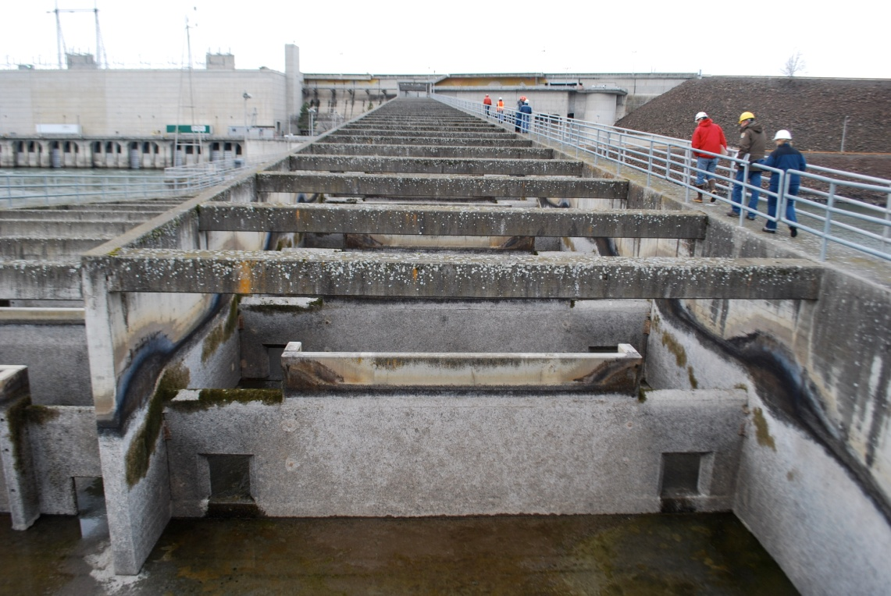
Figure 3. Photographs of TDA East Fish Ladder – Weir 153 (top: facing downstream, from count station; bottom detail of orifice looking upstream to Weir 153). Ramps would be installed on the downstream side of the two submerged orifices seen here.

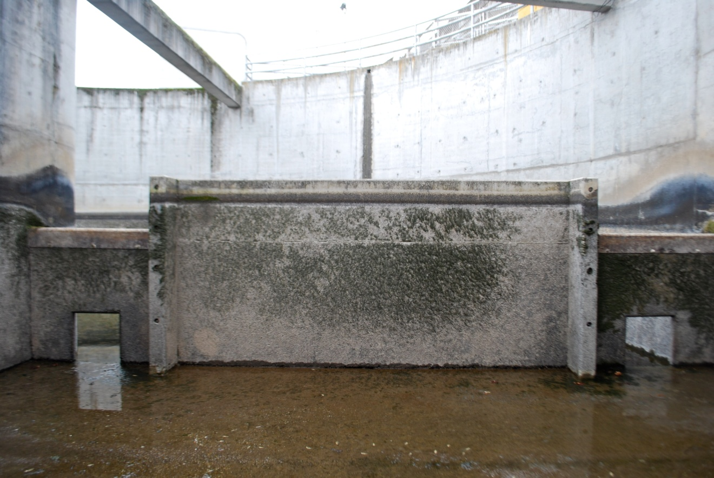

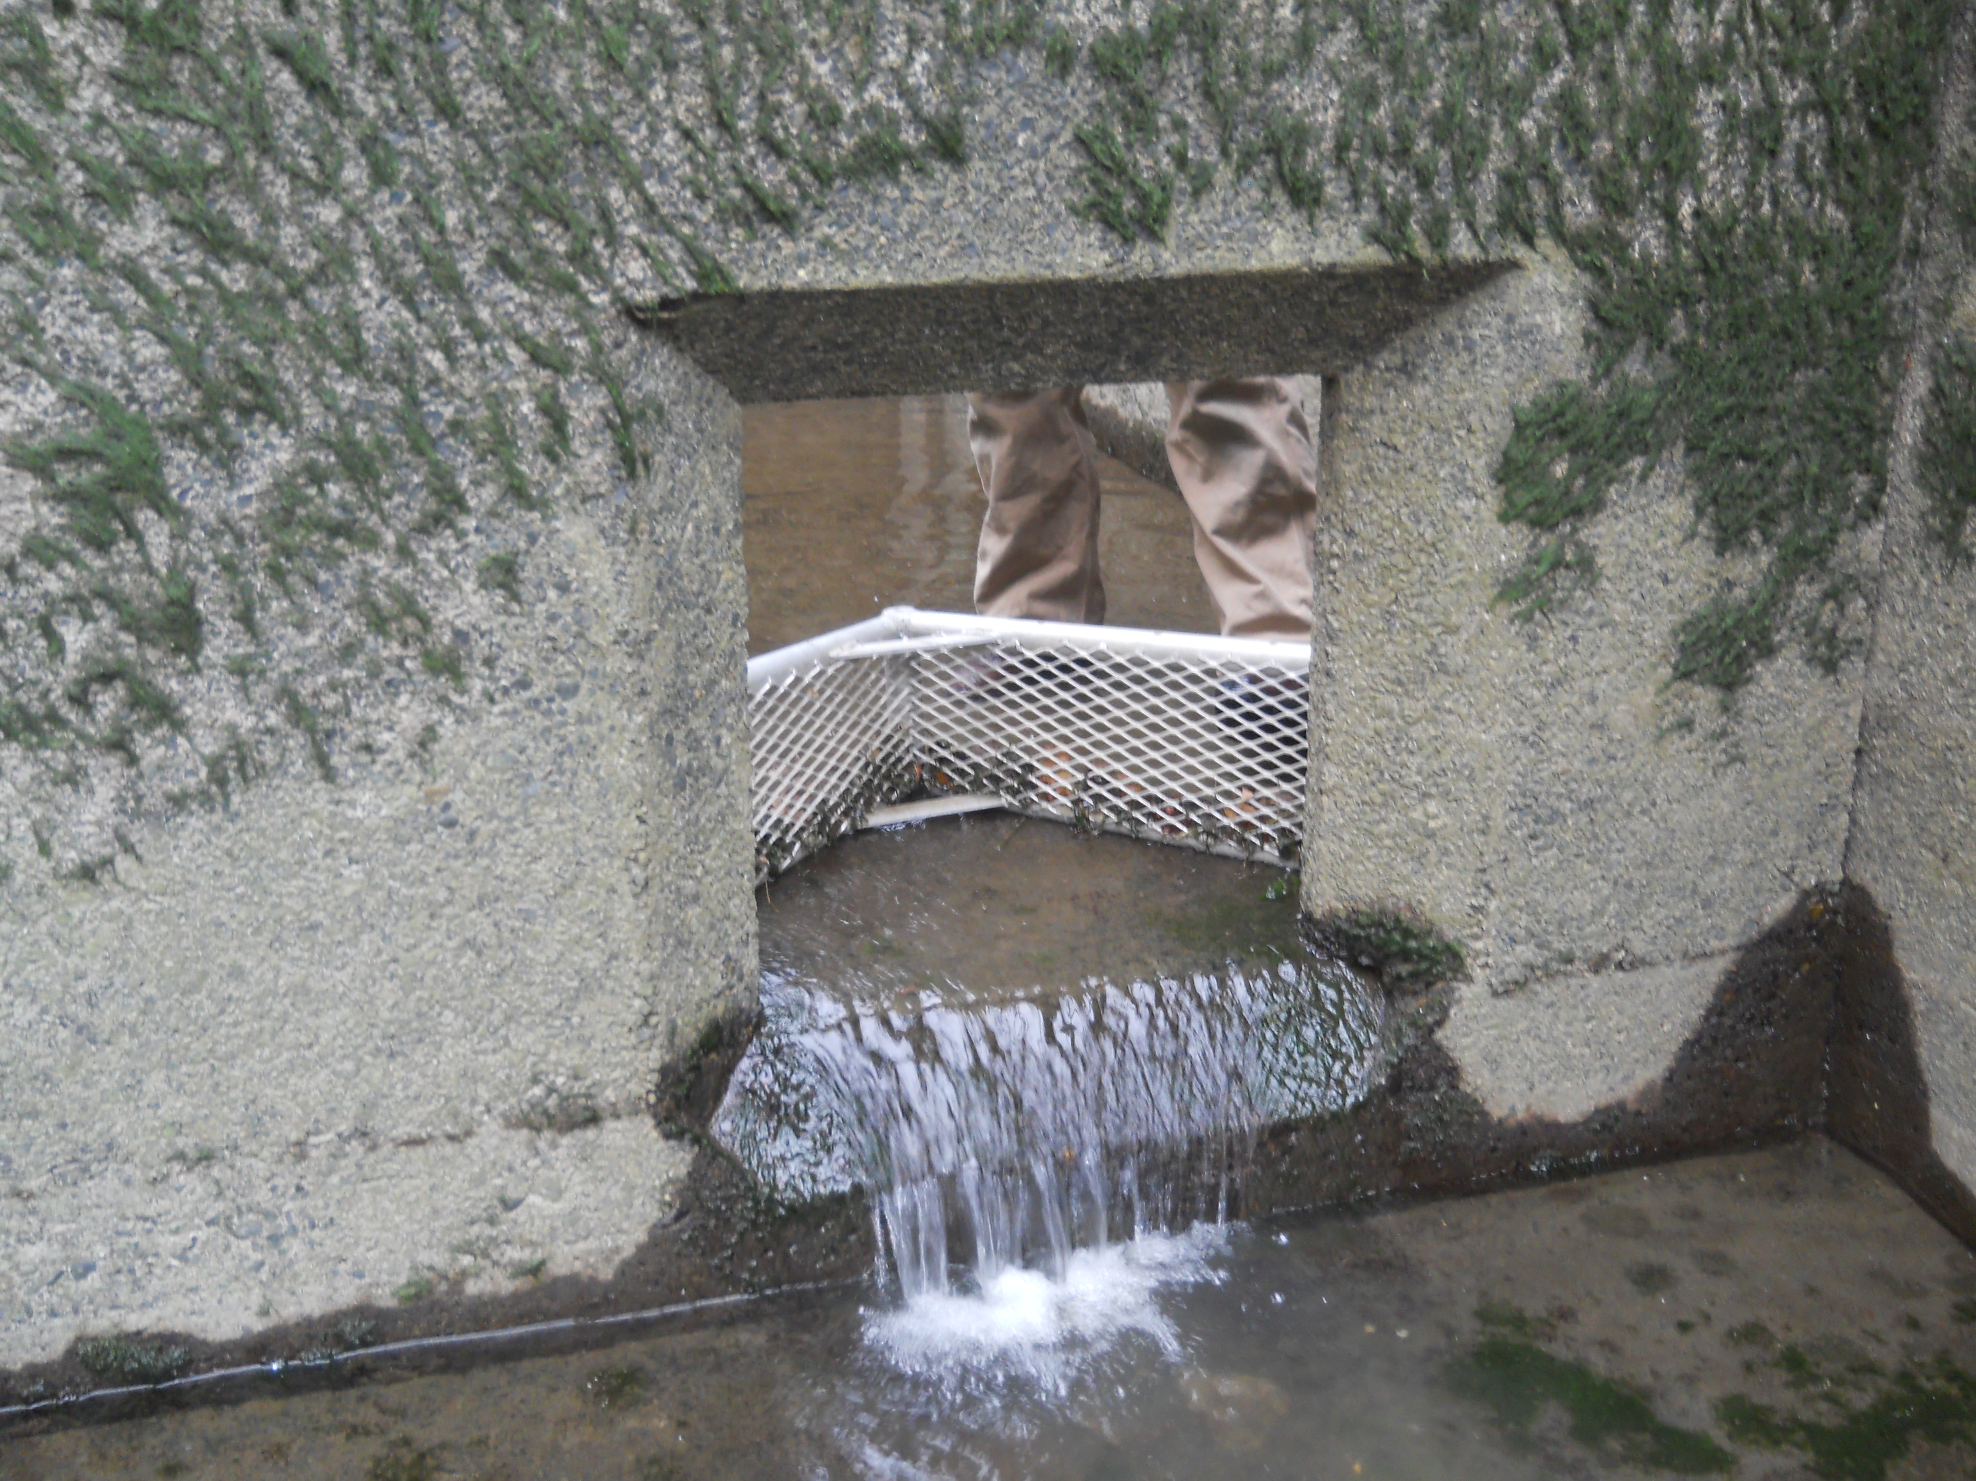
Figure 4. Lamprey ramp installed at the base of picket leads at the Bonneville Dam Washington Shore Fish Ladder count station. The ramp was shown to improve lamprey access to the auxiliary water supply channel at this site in 2011.

